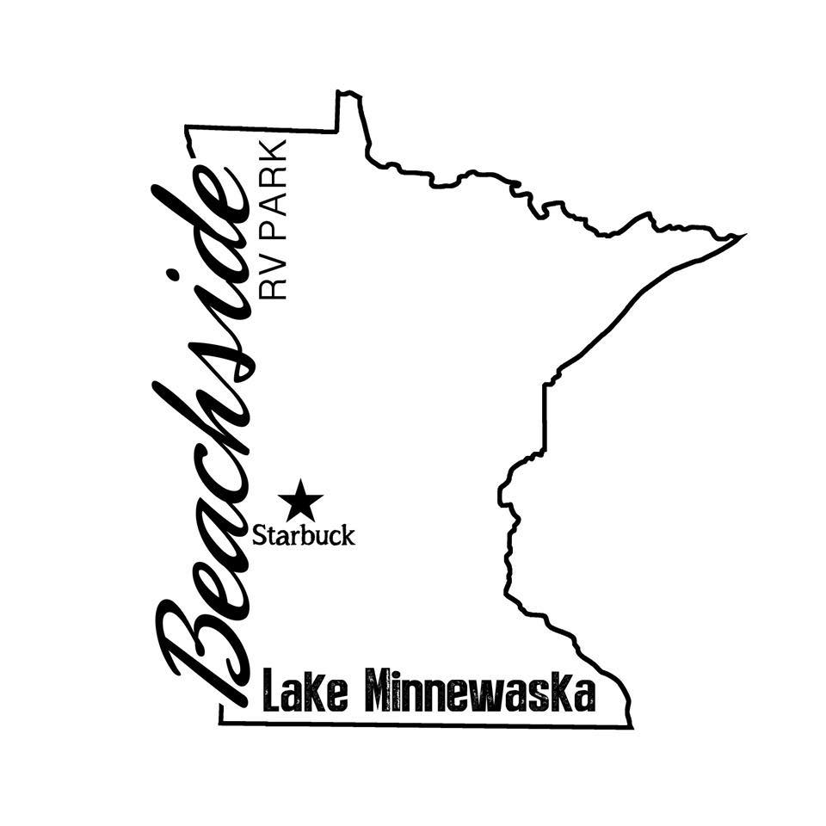

Rules & Regulations
- Speed Limit—Maximum of 5 MPH unless posted otherwise. (PLEASE remind guests if this. It was a HUGE problem last year!!) Licensed drivers only (16 years of age). All vehicles must be street legal.
- ALL campers must be 15 years old or NEWER. We will give a 2 year leeway.
- All campers MUST have current tabs.
- Quiet time is from 11:00 p.m. to 7:00 a.m. Keep music and noise in a subdued manner during this time. This rule will be enforced.
- No more than 2 vehicles at a campsite.
- Pets are allowed. Pets must always be leashed. As a courtesy to our other guests, you must clean up after your pet. Dogs and other pets must not be a threat or a nuisance to other park users. Excessive barking is not allowed
- Public drunkenness or use of drugs may result in immediate eviction.
- We shall have cause to remove any guest who, while on the premises, 1. Disturbs the peace and comfort of other campers. 2. Causes harm to the physical establishment.
- No discharge of firearms or loud noise-making devices allowed in the park. Fireworks are not allowed at any time.
- Beachside RV Park has the right to remove any RV and/or possessions at owner’s expense if site is not vacated at the scheduled time.
- No decks built within 10’ from neighbors RV, no bigger than 14feet wide and must be floating.
- Sheds are allowed and can be no bigger than 8x10.
- All trash must be placed in dumpsters located in the park.
- Beachside RV Park is not responsible for any injuries while using the playground, ALL children MUST be always supervised. Please make sure toys are in the sand if your child used them, upon leaving.
- If you use the clubhouse, please treat it like your own and pick up after yourself!
- Mowing will be done on Thursday’s, please pick up moveable stuff so we can mow. If they aren’t moved and we can’t get around with the mower, that spot will not be mowed. We will not be moving them for you.
- We are not responsible for accidents or injury to our guests and/or visitors.
- Parents are responsible for the actions of their children.
- ALL RV’s MUST have limited liability insurance. Comprehensive insurance is recommended. (We will keep a copy of all insurance cards.)
- As of 2021, NO ATV’s will be allowed within the park. Side by sides/Gators that are Street Legal will be accepted. They are to drive on the shoulder of the highway. They are not allowed on sidewalks or bike paths per Law Enforcement.
- Children are NOT allowed in the Clubhouse without parental supervision.
- All Parents, will need to sign a Waiver form (for each child) for the trampoline. If one is NOT signed or you do not want to sign one, your child will not be allowed to be on the trampoline.
- Shower House, please treat it like it is your own.
- ABSOLUTELY NO PETS IN THE BATHROOMS, THIS MEANS NO GIVING ANIMALS BATHS IN THERE!!
- Washer and dryer will be available in the utility room, please be respectful when using them and be prompt on taking clothes out when done. There will be a donation box in there as well.
- Tents have been an issue, if you are having a tent on your site PLEASE be respectful of your neighbor and not have then touching other campers. If this becomes a problem again there will be no tents.

Golf Cart Rules
- The Driver of the Golf Cart MUST be 16 years or older carry his/her Driver’s License while DRIVING the Golf Cart and must sit in the driver’s seat behind the steering wheel. A LEARNERS PERMIT IS NOT VALID FOR DRIVING GOLF CART.
- Reckless Driving, Racing, horseplay, or misuse of Golf Cart is not permitted and will not be tolerated.
- All passengers must always be seated when Golf Cart is in motion.
- Golf Carts operating after sunset must have the headlights turned on.
- Golf Cart Driver is responsible for any damage to personal property or injury to individuals that result from accidents.
- Golf Carts must be operated properly, safely, and driven on roadways only within the park and where permitted in city limits.
- Golf Cart permits MUST be purchased at the city office. (We will have some forms at the office.)

**** everything in yellow is either new or required! ****

By signing, I acknowledge and will abide by the rules of the campground. They are subject to change, per owner’s discretion.

Signature____________________________________ Date:________________

RV Insurance:
Policy #:_______________________ Carrier: ______________________________
VIN #:_________________________ License Plate #:________________________

