**Beachside RV Park Rules & Regulations**

1. Speed Limit—Maximum of 5 MPH unless posted otherwise**.**(**PLEASE** remind guests of this. It was a HUGE problem a couple years ago!!) Licensed drivers only (16 years of age). All vehicles must be street legal.
2. **ALL** campers must be 15 years old or **NEWER.** We will give a 2-year leeway.
3. **All CAMPERS MUST HAVE CURRENT LICENSE TABS per the county!**
4. Quiet time is from 11:00 p.m. to 7:00 a.m. Keep music and noise in a subdued manner during this time.
5. NO MORE than 2 vehicles at a campsite. Overflow areas are well known, please ask management if there are any questions.
6. Pets are allowed**. Pets must always be leashed**. As a courtesy to our other guests, you must clean up after your pet. Dogs and other pets must not be a threat or a nuisance to other park users. Excessive barking is not allowed. All dog bites will be reported to law enforcement, per law enforcement.
7. Public drunkenness, fighting or use of illegal drugs may result in immediate eviction.
8. We shall have cause to remove any guest who, while on the premises, who: **1.** Disturbs the peace and comfort of other campers. **2.** Causes harm to the physical establishment or others.
9. Beachside RV Park has the right to remove any RV and/or possessions at owner’s expense if the site is not vacated at the scheduled time.
10. No decks shall be built within 10’ from neighbors RV, no bigger than 14 feet wide and must be floating. All attachments, decks included need to be approved by management.
11. Sheds are allowed and can be no bigger than 8x10.
12. All trash must be placed in dumpsters located in the park. If Garbage Dumpsters smell, please notify management. **Always Breakdown boxes** or you will get yelled at!
13. Beachside RV Park is not responsible for any injuries while using the playground, ALL children MUST be always supervised. Please make sure toys are in the sand if your child uses them upon leaving.
14. If you use the clubhouse / Red house, please treat it like your own and pick up after yourself. Please return the furniture back to the way you found it.
15. Mowing will be done on Thursday’s, please pick up moveable stuff so we can mow. If they aren’t moved and we can’t get around with the mower, that spot will not be mowed. We will not be moving them for you.
16. Trimming around campers will be the responsibility of the lot tenant. We will do around the common areas. Trimming Tools are available to use, please ask management for location of those tools to use **at your own risk**.
17. We are not responsible for accidents or injury to our guests and/or visitors.
18. **Parents are responsible for the actions of their children.**
19. **ALL** RV’s **MUST** have limited liability insurance. Comprehensive insurance is recommended. (We will keep a copy of all insurance cards.)
20. **As of 2021,** NO ATV’s will be allowed within the park. Side by sides/Gators that are Street Legal will be accepted. They are to drive per State & City ordinances.
21. Children are NOT allowed in the Clubhouse/Red house without parental supervision.
22. All Parents will need to sign a Waiver form (for each child) for the trampoline. If one is NOT signed or you do not want to sign one, your child will not be allowed to be on the trampoline. Blank Waivers are available at red house office.
23. Shower House, please treat it like it is your own. If it needs attention, please let us know. Please make sure the lights are off, and doors are shut at night!
24. **ABSOLUTELY NO PETS IN THE BATHROOMS OR CLUBHOUSE/RED HOUSE! (Unless in emergency situations)**
25. A washer and dryer will be available in the utility room, please be respectful when using them and be prompt on taking clothes out when done. There will be a donation box in there as well.
26. Tents have been an issue, if you are having a tent on your site, PLEASE be respectful of your neighbor and not have then touching other campers. If this becomes a problem again there will be no tents.
27. The ice machine will be located under the overhang at the red house. There will be a money box next to it.
28. Storm Shelter is in the Basement of (Myron’s House) if shelter is needed during severe weather.
29. No For Sale signs on campers! You can list it, but please don’t put up signs on campers!

**Golf Cart Rules**

1. **The Driver of the Golf Cart MUST be 16 within the park.** City rules are 13 **with** an adult or a licensed driver outside of the RV Park. **A LEARNER’S PERMIT IS NOT VALID FOR DRIVING GOLF CART**.
2. Reckless Driving, Racing, horseplay, or misuse of Golf Cart is not permitted and will not be tolerated.
3. **All passengers must always be seated when the Golf Cart is in motion.**
4. Golf Carts operating after sunset must have the headlights turned on.
5. Golf Cart Driver is responsible for any damage to personal property or injury to individuals that result from accidents.
6. Golf Carts must be operated properly, safely, and driven on roadways only within the park and where permitted in city limits. Golf Cart permits **MUST** be purchased at the city office.
7. A golf cart on a white background

   Description automatically generated

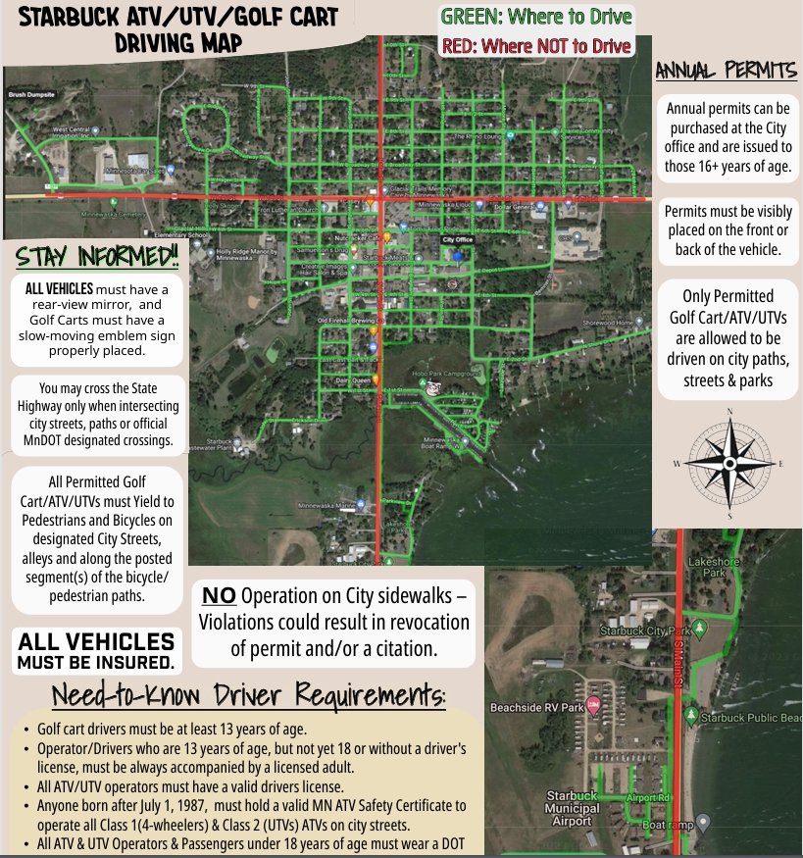

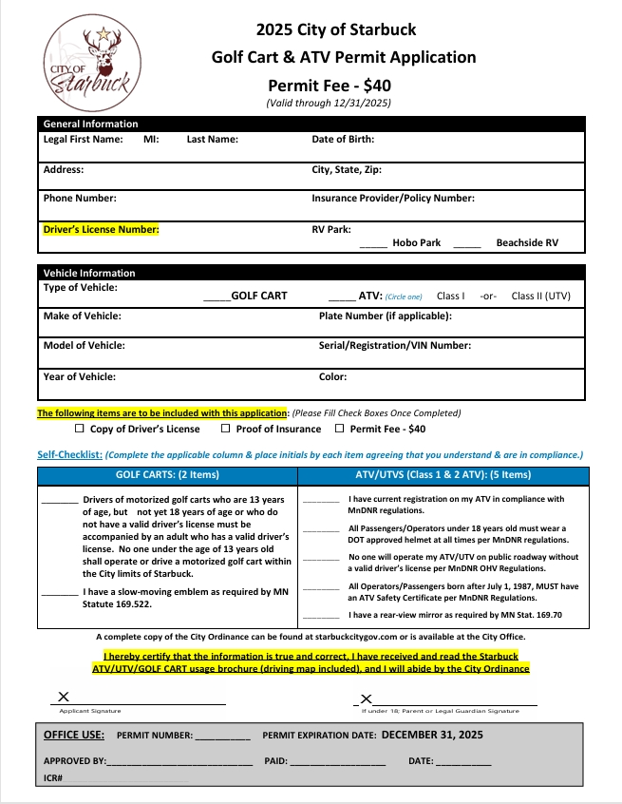

By signing, I acknowledge and will abide by the rules of the campground. They are subject to change, according to the owner’s discretion.

Signature____________________________________ Date:________________

RV Insurance:

Policy #:_______________________ Carrier: ______________________________

VIN #:_________________________ License Plate #:________________________